* **Personal Loan Module:**

**1. PL Bank Master: -**

* Click on PL Bank master

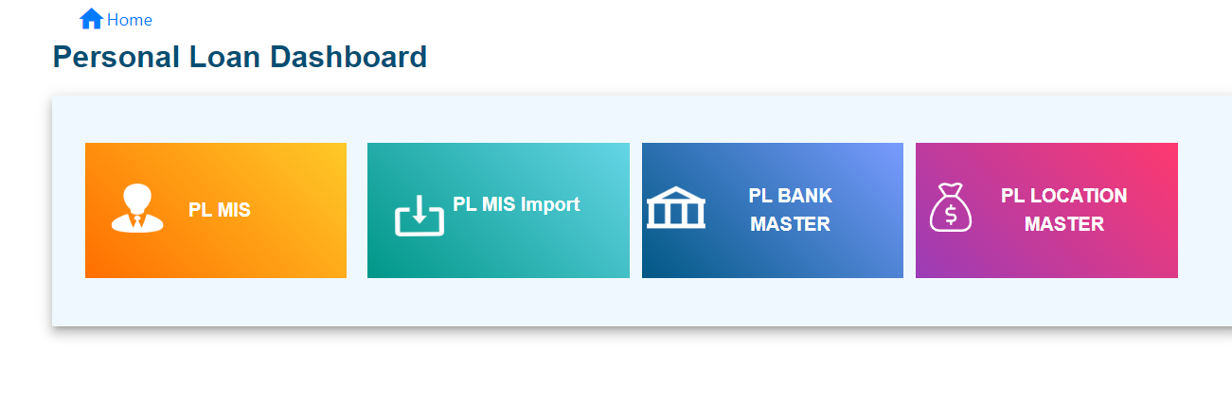

* Enter Bank Name
* Click on create

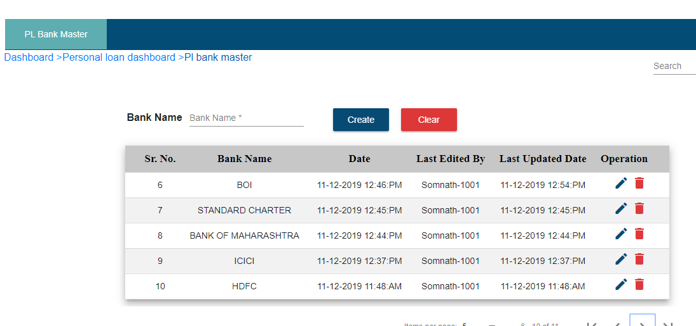

* User can edit the created bank name, by clicking on edit icon present in operation column.



* User can delete the created bank name, by clicking on delete icon present in operation column.



**2. PL Location Master: -**

* Click on PL Location Master



* Location master contains three types of location i.e. Prime, Emerging, Out of state. User can be able to change deduction percentage by clicking on edit icon present in operation column

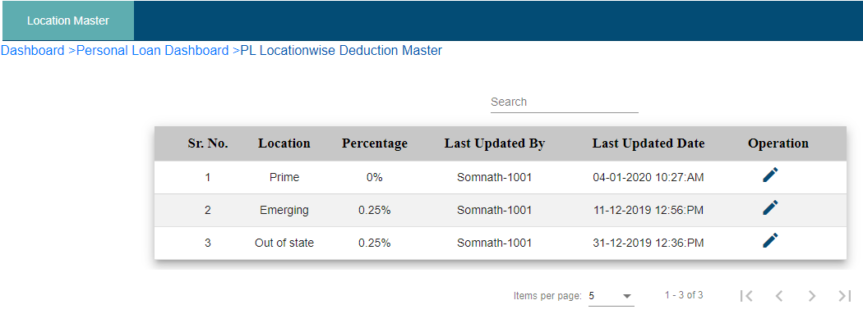

* Change Percentage
* Click on Update
* If you want to clear entered percentage then click on clear

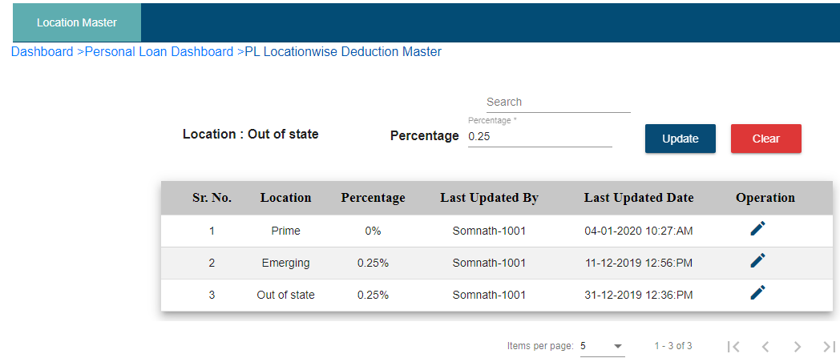

**3. PL MIS: -**

* Click on PL MIS module



* Click on add PL

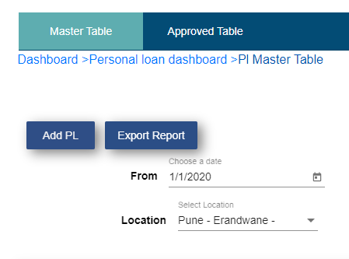

* Select lead type from dropdown menu

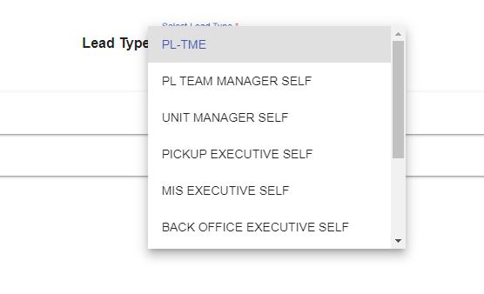

* Click on PL-MIS form
* Enter all fields (“*” indicates mandatory fields)

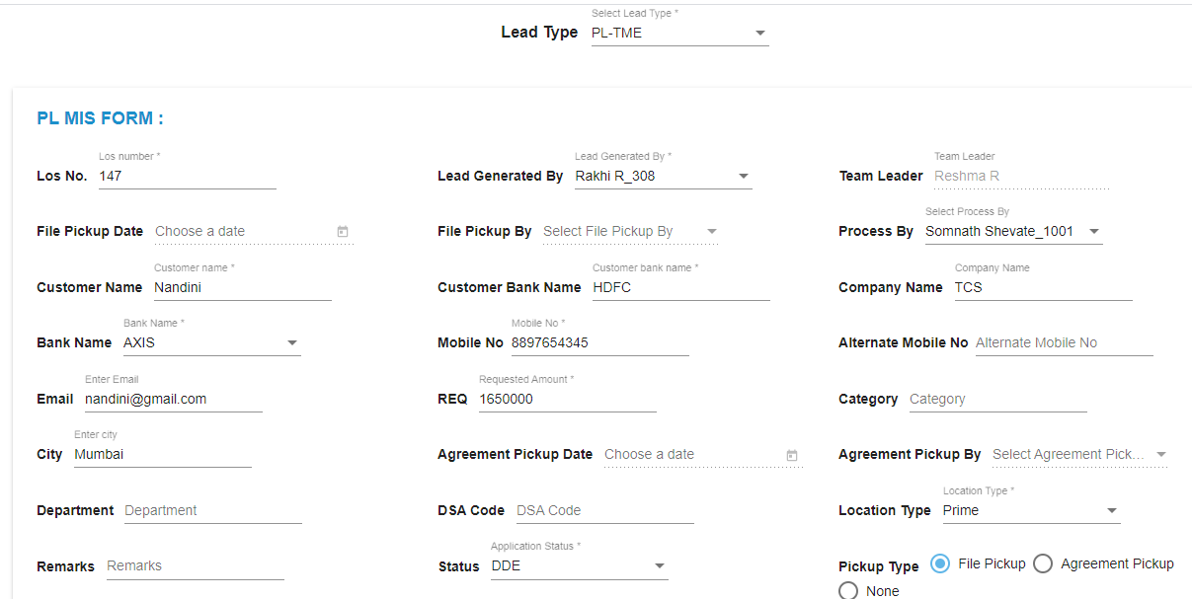

* If there is need to collect documents then click on File pickup or Agreement pickup, if not then click on none.
* If click on file pickup or agreement pickup then click on PL pickup Document

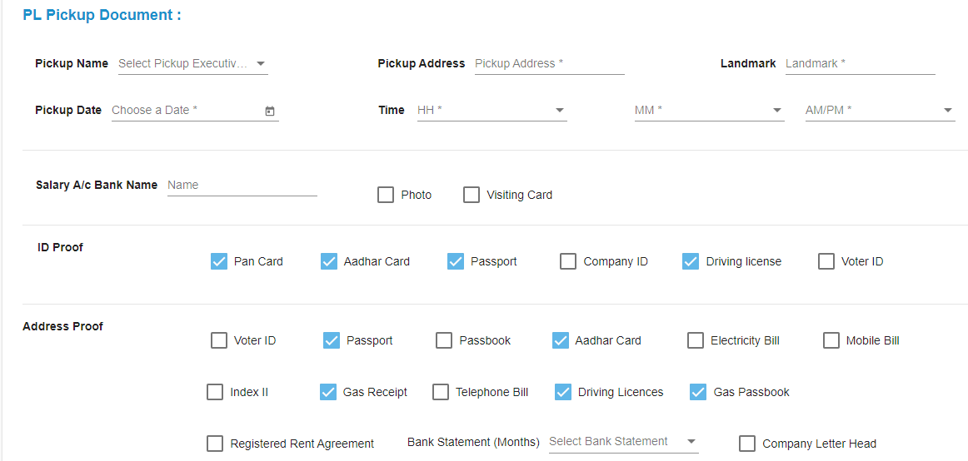

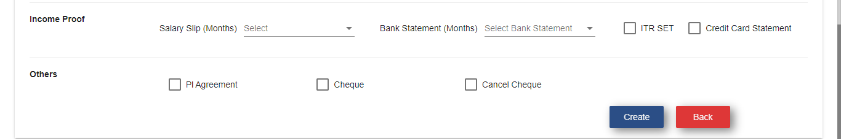

* Fill all fields
* Select necessary documents that will take from customer
* Click on create.
* If selected pickup executive submit collected documents from mobile app, then file pickup date / agreement pickup date automatically filled in file pickup date / agreement pickup date field.





* If Created lead status is other than approved, then it displayed in master table of lead generated employee and to MIS executive, Backoffice executive, super admin master table.
* Lead generated by all employee is visible to MIS executive, Backoffice executive, super admin master table.

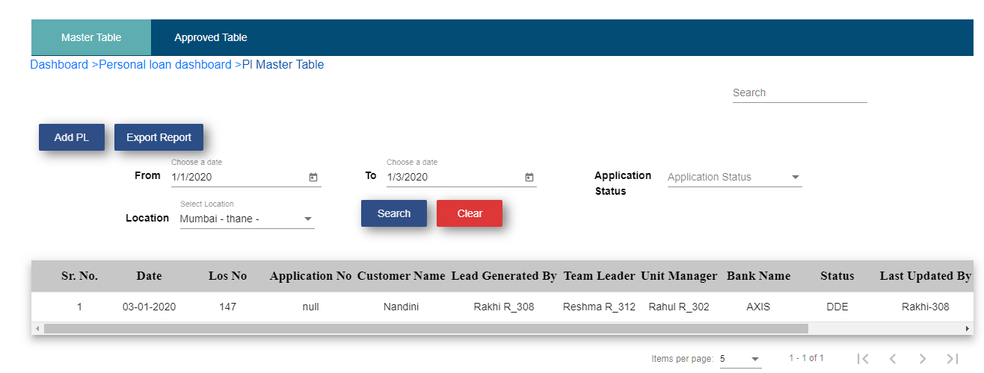

* MIS executive / Backoffice executive edit that lead, he/she has to fill the fields which are only visible to him/her like application number, disbursed amount, sanctioned amount, Eligibility Amount, Disbursed date, etc. and approved option.
* Click on Update

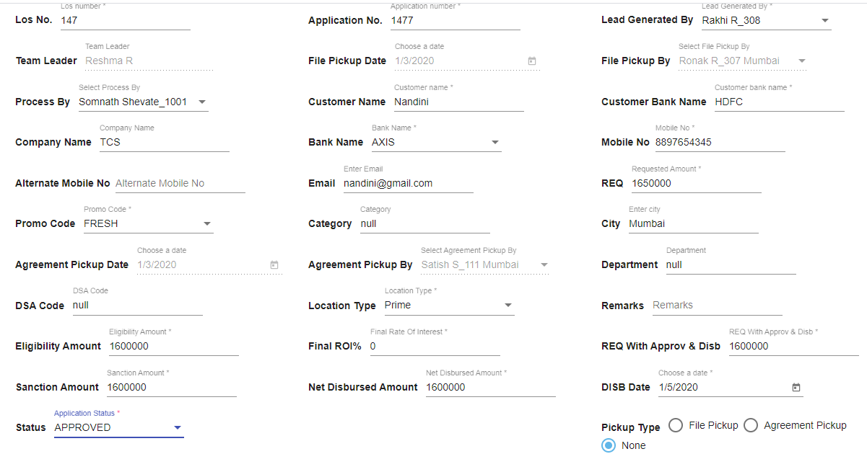

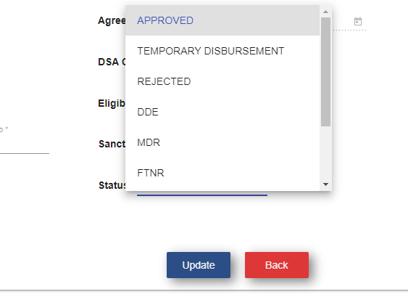

* Change the lead status according to condition. If they change the status approved then lead is disappeared from master table and display in approved table of MIS executive, Backoffice executive, super admin and lead generated employee approved table.

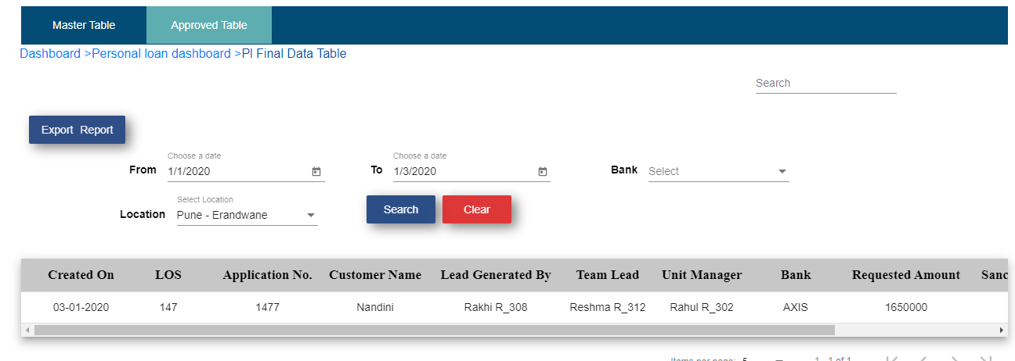

* User can see the details by clicking on view details icon present in last column.
* **Export Report:**
* If you click on export report from master table then you get the excel sheet of PL MIS Master Report.



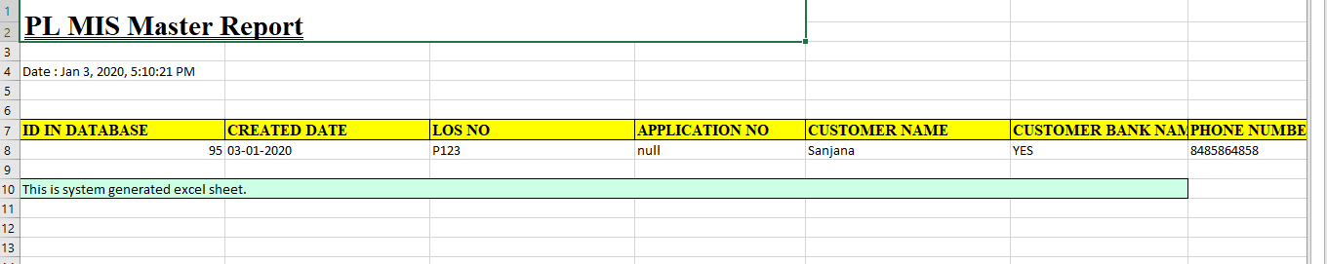

* If you click on export report from approved table then you get the excel sheet of PL MIS Approved Report.

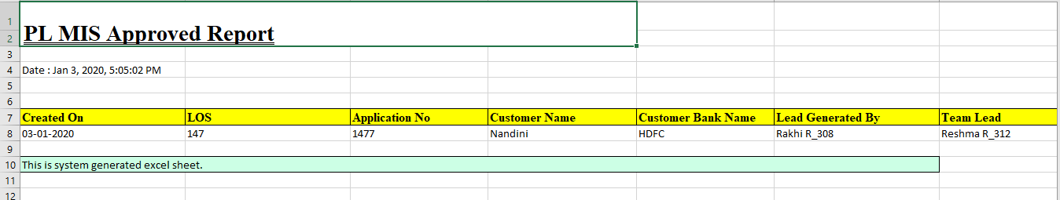

**4. PL MIS Import: -**



* Click on sample sheet

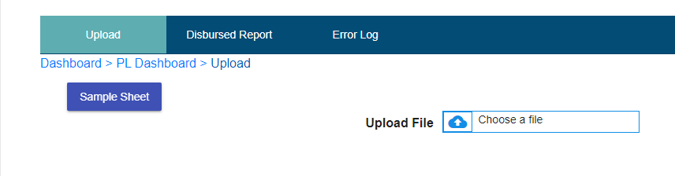

* Click on Export

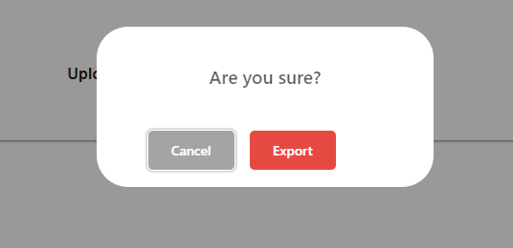

* Click on Ok
* Sample sheet get downloaded, according to that user can fill the sheet using customer details present in approved table. LOS number is necessary. All the field formats are as per sheet only otherwise sheet would not be uploaded. If user enter wrong LOS number then customer goes in error log tab.
* **Upload**
* Click on choose a file



* Select that sheet
* Click on upload data
* Click on OK

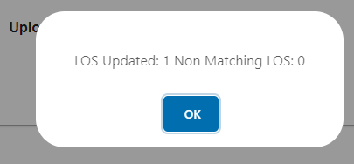

Now this customer disappears from approved table and appears in Disbursed Report. User is able to see the customer details and total disbursed amount in it.

* **Disbursed Report:**

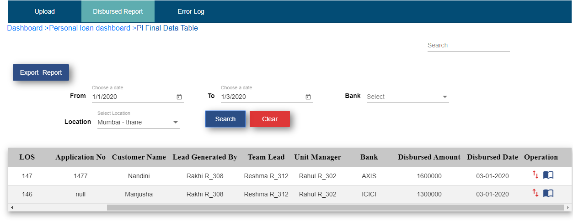

* **Error Log: -**

If wrong LOS number is entered in sheet and try to enter, it displays Non matching LOS count on pop up window. If we click on ok then this entered customer details goes in error log.

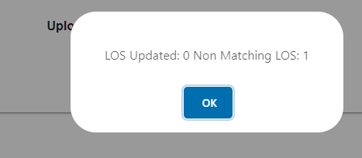

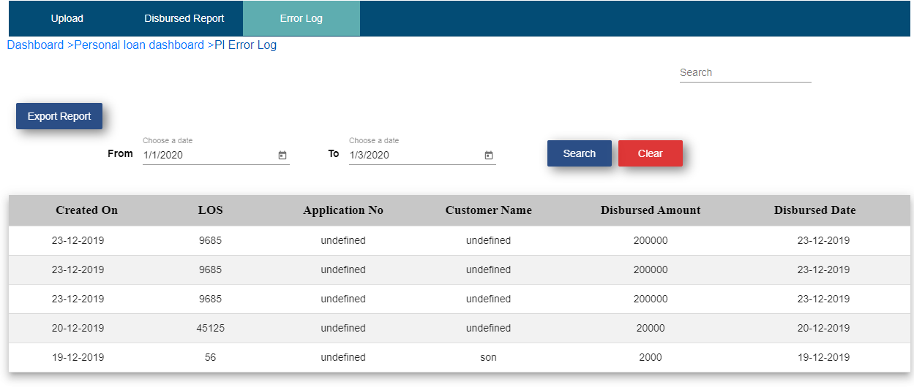

* **Export Report: -**
* Click on export report



* Click on export
* Click on Ok
* User will get the Excel sheet of PL MIS Disbursed Report

